1. **HOME**

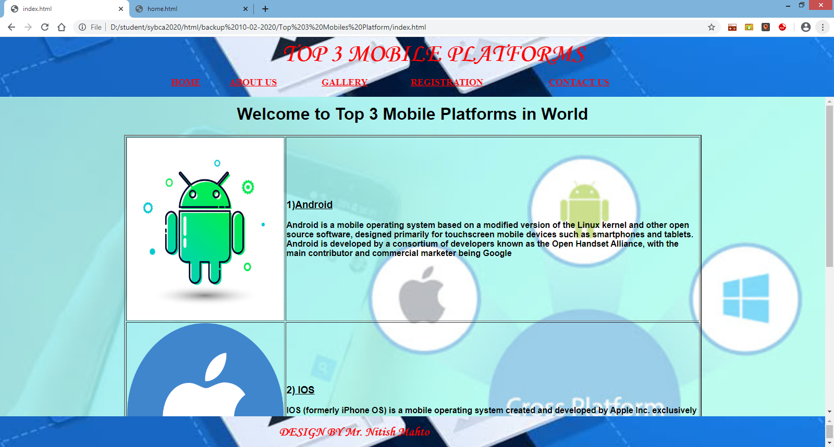

Coding:

<html>

<style>

body{

margin:0;

padding:0;

background: url(images/banner9.png);

background-size: cover;

background-position: center;

font-family: sans-serif;

color: lavander;

margin-top:15px;

}

</style>

<body >

<div align="center"><h1>Welcome to Top 3 Mobile Platforms in World</h1></div>

<table width="70%" align='center' border=2>

<tr>

<td><img src="images/android6.png" width='300px' height="350px"></td>

<td><h3>1)<u>Android</u></h3>

<b>

Android is a mobile operating system based on a modified version of the Linux kernel and other open source software, designed primarily for touchscreen mobile devices such as smartphones and tablets. Android is developed by a consortium of developers known as the Open Handset Alliance, with the main contributor and commercial marketer being Google</b>

</td>

</tr>

<tr>

<td><img src="images/ios1.png" width='300px' height="350px"></td>

<td><h3>2)<u> IOS</u></h3>

<b>

IOS (formerly iPhone OS) is a mobile operating system created and developed by Apple Inc. exclusively for its hardware. It is the operating system that presently powers many of the company's mobile devices, including the iPhone, and iPod Touch; it also powered the iPad prior to the introduction of iPadOS in 2019. It is the second most popular mobile operating system globally after Android

</b>

</td>

</tr>

<tr>

<td><img src="images/window1.png" width='300px' height="350px"></td>

<td><h3>3)<u> Window</u></h3>

<b>

Windows Mobile is a discontinued family of mobile operating systems developed by Microsoft for smartphones and Pocket PCs.[1]

Its origin dated back to Windows CE in 1996, though Windows Mobile itself first appeared in 2000 as Pocket PC 2000. It was renamed "Windows Mobile" in 2003, at which point it came in several versions (similar to the desktop versions of Windows) and was aimed at business and enterprise consumers. When initially released in the mid-2000s, it was to be the portable equivalent of what Windows ' desktop OS was; a major force in the then-emerging mobile/portable areas, but its popularity - always the low end of the market, never equalled nor surpassed other mobile OS' (iOS and Android), and faded rapidly in the following years

</b>

</td>

</tr>

</table>

</body>

</html>

1. **ABOUT US**

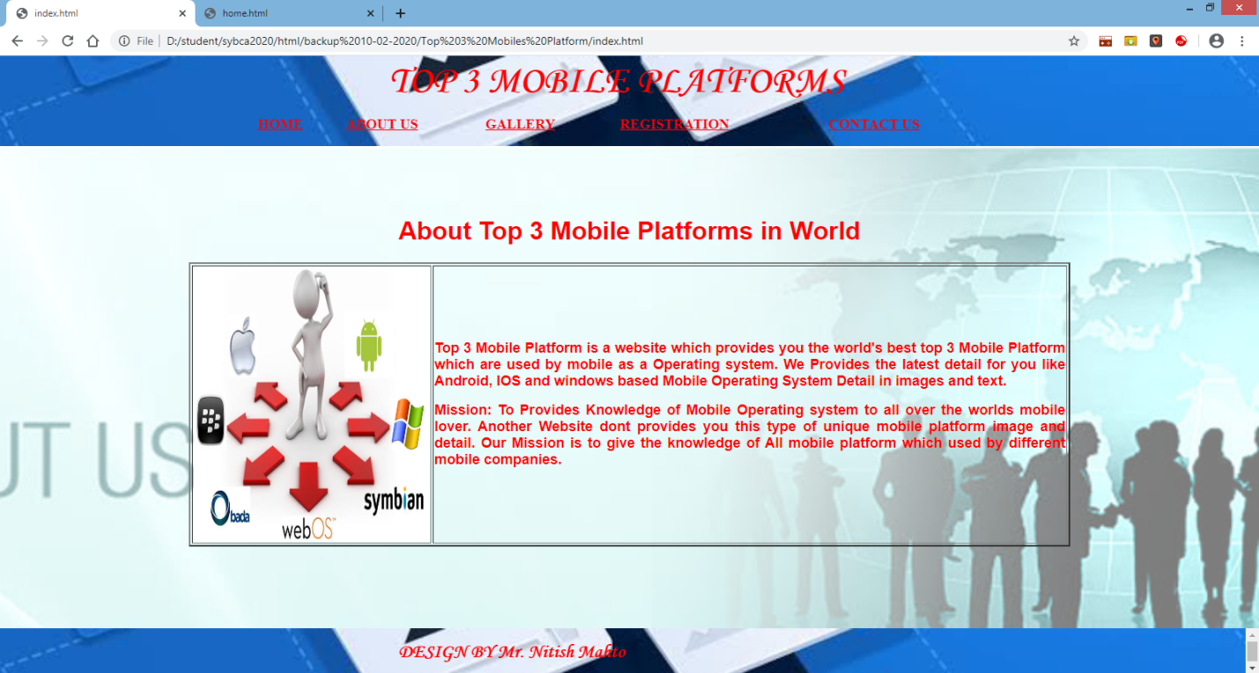

Coding:

<html>

<style>

body{

margin:0;

padding:0;

background: url(images/abtbanner1.png);

background-size: cover;

background-position: center;

font-family: sans-serif;

color: lavander;

color: red;

margin-top:90px;

}

</style>

<body>

<div align="center"><h1>About Top 3 Mobile Platforms in World</h1></div>

<table width="70%" align='center' border=2>

<tr>

<td><img src="images/abt1.jpg" width='300px' height="350px"></td>

<td><p align='justify' ><font color="red" size='4'><b>

Top 3 Mobile Platform is a website which provides you the world's best top 3 Mobile Platform which are used by mobile as a Operating system.

We Provides the latest detail for you like Android, IOS and windows based Mobile Operating System Detail in images and text.

</b>

</font>

<p align='justify' ><font color="red" size='4'><b>

Mission: To Provides Knowledge of Mobile Operating system to all over the worlds mobile lover. Another Website dont provides you this type of unique mobile platform image and detail.

Our Mission is to give the knowledge of All mobile platform which used by different mobile companies.

</b>

</font>

</td>

</tr>

</table>

</body>

</html>

1. **GALLERY**

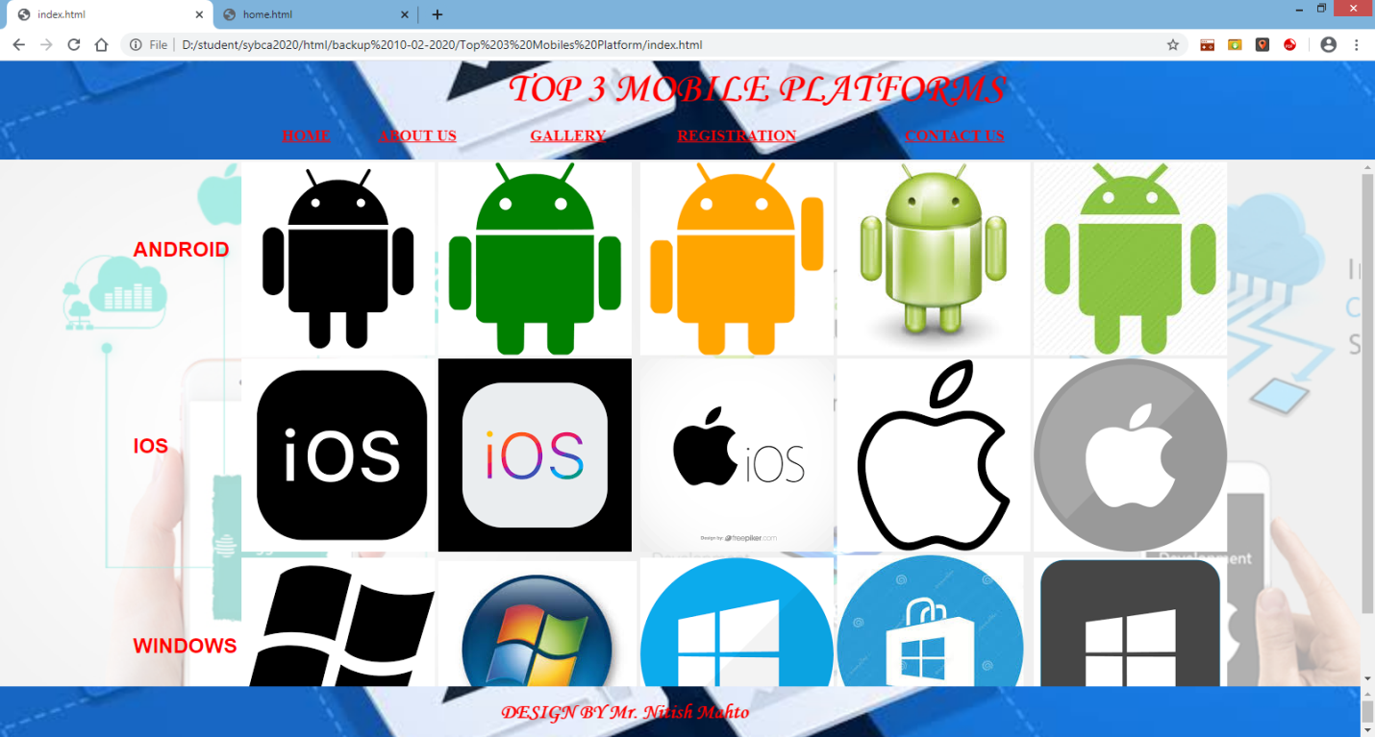

Coding:

<html>

<style>

body{

margin:0;

padding:0;

background: url(images/banner4.png);

background-size: cover;

background-position: center;

font-family: sans-serif;

color: red;

}

</style>

<body >

<table align="center" width="70%">

<tr>

<td><h2>ANDROID</h2></td>

<td><img src="a\download (1).png"></td>

<td><img src="a\download (2).png"></td>

<td><img src="a\download (3).png"></td>

<td><img src="a\images (5).jpg"></td>

<td><img src="a\download.jpg"></td>

</tr>

<tr>

<td><h2>IOS</h2></td>

<td><img src="i\download (1).png"></td>

<td><img src="i\download (4).png"></td>

<td><img src="i\download (5).png"></td>

<td><img src="i\images (2).png"></td>

<td><img src="i\images (1).png"></td>

</tr>

<tr>

<td><h2>WINDOWS</h2></td>

<td><img src="w\images.png"></td>

<td><img src="w\images (5).jpg"></td>

<td><img src="w\download.png"></td>

<td><img src="w\images (3).jpg"></td>

<td><img src="w\images (4).png"></td>

</tr>

</table>

</body>

</html>

1. **REGISTRATION**

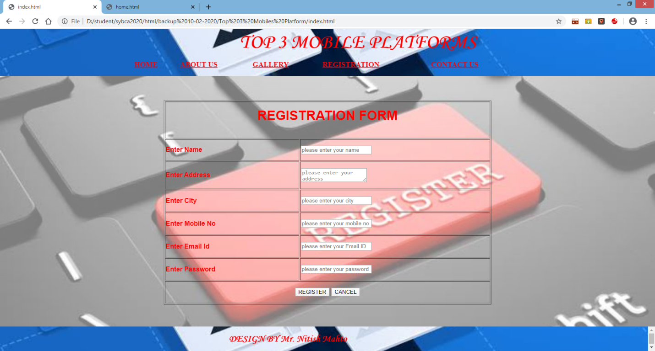

Coding:

<html>

<style>

body{

margin:0;

padding:0;

background: url(images/regisbanner3.png);

background-size: cover;

background-position: center;

font-family: sans-serif;

color: red;

margin-top:60px;

}

</style>

<body >

<script type="text/javascript">

function validation(form)

{

var flag=true;

var v=/^[a-zA-Z ]+$/

if(form.txtname.value=="")

{

document.getElementById("error_name").innerHTML="*Please Enter Your Name";

form.txtname.focus();

flag=false;

}else if(!v.test(form.txtname.value))

{

document.getElementById("error_name").innerHTML="*Please Enter Only characters in Name";

form.txtname.focus();

flag=false;

}else{

document.getElementById("error_name").innerHTML="";

}

if(form.txtadd.value=="")

{

document.getElementById("error_add").innerHTML="*Please Enter Your Address";

form.txtadd.focus();

flag=false;

}else{

document.getElementById("error_add").innerHTML="";

}

if(form.txtcity.value=="")

{

document.getElementById("error_city").innerHTML="*Please Enter Your City Name";

form.txtcity.focus();

flag=false;

}else if(!v.test(form.txtcity.value))

{

document.getElementById("error_city").innerHTML="*Please Enter Only characters in City Name";

form.txtcity.focus();

flag=false;

}else{

document.getElementById("error_city").innerHTML="";

}

var v=/^[0-9]+$/

if(form.txtmno.value=="")

{

document.getElementById("error_mno").innerHTML="*Please Enter Your Mobile No";

form.txtmno.focus();

flag=false;

}else if(form.txtmno.value.length!=10){

document.getElementById("error_mno").innerHTML="*Please Enter 10 Digits in Mobile No";

form.txtmno.focus();

flag=false;

}else if(!v.test(form.txtmno.value))

{

document.getElementById("error_mno").innerHTML="*Please Enter Only Digits in Mobile No";

form.txtmno.focus();

flag=false;

}else{

document.getElementById("error_mno").innerHTML="";

}

var v=/^[a-zA-Z0-9.-_]+@[a-zA-Z0-9.-_]+\.([a-zA-Z]{2,4})$/

if(form.txtemail.value=="")

{

document.getElementById("error_email").innerHTML="*Please Enter Email ID";

form.txtemail.focus();

flag=false;

}else if(!v.test(form.txtemail.value))

{

document.getElementById("error_email").innerHTML="*Please Enter Proper Email ID";

form.txtemail.focus();

flag=false;

}else{

document.getElementById("error_email").innerHTML="";

}

if(form.txtpwd.value=="")

{

document.getElementById("error_pwd").innerHTML="*Please Enter Your Password";

form.txtpwd.focus();

flag=false;

}else if(form.txtpwd.value.length<6){

document.getElementById("error_pwd").innerHTML="*Please Enter Password More Than 6 Characters";

form.txtpwd.focus();

flag=false;

}else if(form.txtpwd.value.length>10){

document.getElementById("error_pwd").innerHTML="*Please Enter Password Less Than 10 Characters";

form.txtpwd.focus();

flag=false;

}else{

document.getElementById("error_pwd").innerHTML="";

}

if(flag==true){

alert("Register Successfull");

window.location.href="home.html";

}

}

</script>

<form>

<table width="50%" align="center" border="1" height="500px">

<tr>

<th colspan="2"><h1>REGISTRATION FORM</h1></th>

</tr>

<tr>

<td><b>Enter Name</b></td>

<td><input type="text" name="txtname" placeholder="please enter your name">

<span id="error_name" style="color:red;"></span>

</td>

</tr>

<tr>

<td><b>Enter Address</b></td>

<td><textarea name="txtadd" placeholder="please enter your address"></textarea>

<span id="error_add" style="color:red;"></span>

</td>

</tr>

<tr>

<td><b>Enter City</b></td>

<td><input type="text" name="txtcity" placeholder="please enter your city">

<span id="error_city" style="color:red;"></span>

</td>

</tr>

<tr>

<td><b>Enter Mobile No</b></td>

<td><input type="text" name="txtmno" placeholder="please enter your mobile no">

<span id="error_mno" style="color:red;"></span>

</td>

</tr>

<tr>

<td><b>Enter Email Id</b></td>

<td><input type="text" name="txtemail" placeholder="please enter your Email ID">

<span id="error_email" style="color:red;"></span>

</td>

</tr>

<tr>

<td><b>Enter Password</b></td>

<td><input type="password" name="txtpwd" placeholder="please enter your password">

<span id="error_pwd" style="color:red;"></span>

</td>

</tr>

<tr>

<td COLSPAN="2" ALIGN="CENTER">

<input type="button" name="btnregis" value="REGISTER" onclick="validation(form);">

<input type="reset" name="btncancel" value="CANCEL">

</td>

</tr>

</table>

</form>

</body>

</html>

1. **CONTACT US**

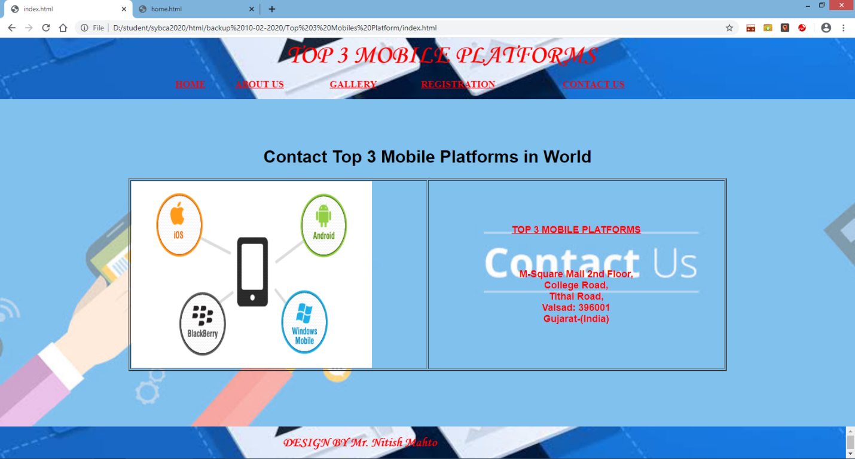

Coding:

<html>

<style>

body{

margin:0;

padding:0;

background: url(images/cntbanner1.png);

background-size: cover;

background-position: center;

font-family: sans-serif;

color: lavander;

margin-top:90px;

}

</style>

<body >

<div align="center"><h1>Contact Top 3 Mobile Platforms in World</h1></div>

<table width="70%" align='center' border=2>

<tr>

<td width="50%"><img src="images/cnt1.png" width='450px' height="350px"></td>

<td align="center">

<p ><font color="red" size='4'><b>

<h2> <u>TOP 3 MOBILE PLATFORMS</u></h2>

<br/><br/>

M-Square Mall 2nd Floor,<br/>

College Road,<br/>

Tithal Road,<br/>

Valsad: 396001 <br/>

Gujarat-(India)

</b>

</font>

<p align='justify' ><font color="red" size='4'><b>

</b>

</font>

</p>

</td>

</tr>

</table>

</body>

</html>

1. **FOOTER**

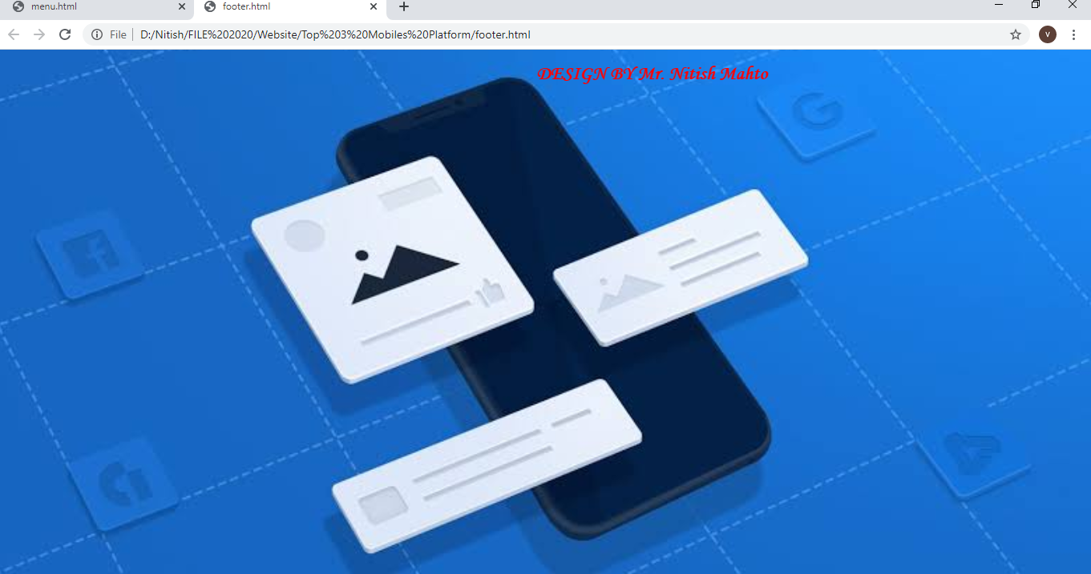

Coding:

<html>

<head>

</head>

<body style="background:url('images/banner2.jpg'); background-size: cover;

background-position: center;">

<marquee behavior="scroll" hspace="10px" vspace="10px"

scrolldelay="1000" scrollamount="50">

<font size="5" color="red" face="Monotype Corsiva">

<b>DESIGN BY Mr. Nitish Mahto</b>

</font>

</marquee>

<br/>

</body>

</html>

1. **INDEX**

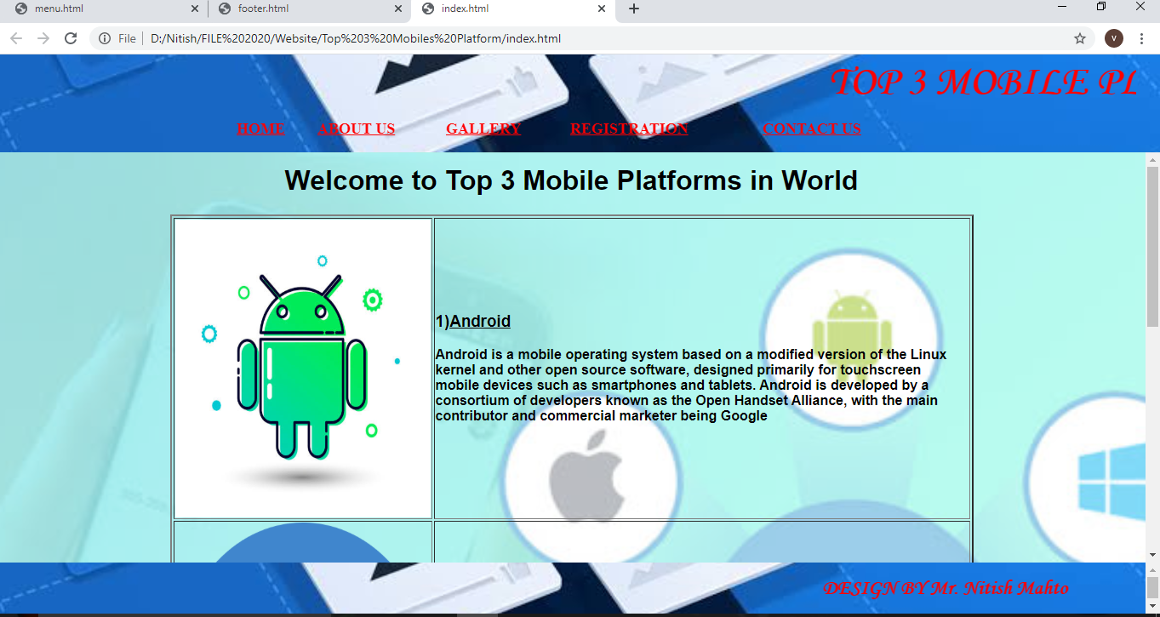

Coding:

<html>

<head>

<frameset rows="115px,*,60px" border="0">

<frame src="menu.html" noresize>

<frame src="home.html" name="display" noresize>

<frame src="footer.html" noresize>

</frameset>

</head>

</html>

1. **MENU**

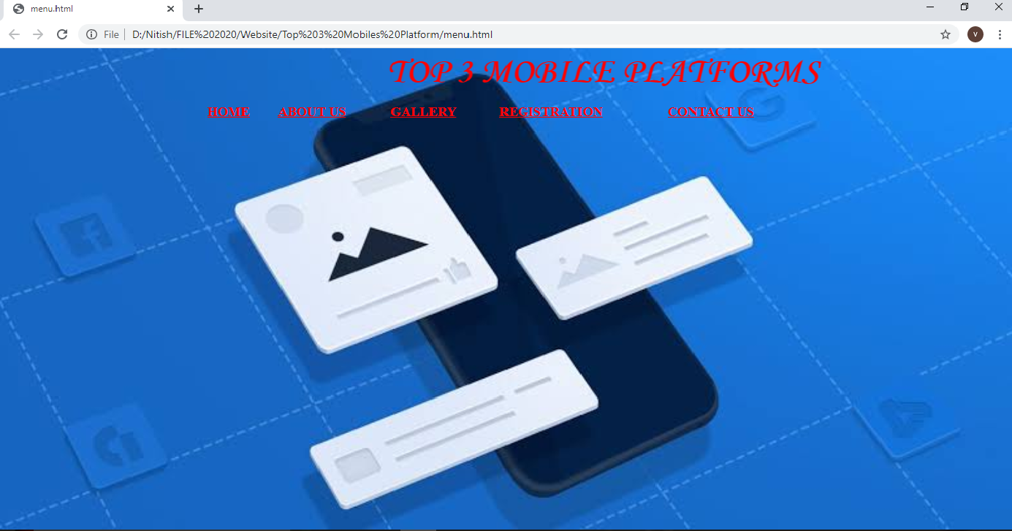

Coding:

<html>

<head>

</head>

<body LINK="red" vlink="green" alink="pink" style="background:url('images/banner2.jpg'); background-size: cover;

background-position: center;">

<marquee behavior="scroll" hspace="20px"

scrolldelay="1000" scrollamount="50"><font size="7" color="red" face="Monotype Corsiva"><b>TOP 3 MOBILE PLATFORMS</b></font></marquee>

<br/>

<table width='60%' align='center' style="margin-top:12px;">

<tr>

<td><a href="home.html" target="display"><font color="red" size="4"><b>HOME</b></font></a></td>

<td><a href="aboutus.html" target="display"><font color="red" size="4"><b>ABOUT US</b></font></a></td>

<td><a href="gallery.html" target="display"><font color="red" size="4"><b>GALLERY</b></font></a></td>

<td><a href="regis.html" target="display"><font color="red" size="4"><b>REGISTRATION</b></font></a></td>

<td><a href="contactus.html" target="display"><font color="red" size="4"><b>CONTACT US</b></font></a></td>

</tr>

</table>

</body>

</html>